Computing Curriculum Intent Statement
Subject | Computing | Subject Lead | Michael Kelly

Contents
Vision 1
Computing Curriculum Overview: 2
Updated Computing Curriculum 2023-2024 3
After School Clubs 8
Assessment in Computing: 8

Vision
Computing lessons at Rotherfield and Newington Green primary school encourage children to be creative and independent learners. Our work in lessons will develop problems solving skills and will enable learners to confidently complete tasks using a variety of digital devices, apps and online platforms.
The Computing curriculum has three fundamental strands:
- Computer Science develops computational thinking and problem-solving skills, introduces algorithms, coding, and logical reasoning.
- Information Technology covers practical aspects of using technology effectively, including software applications, hardware components, and computer networks.
- Digital Literacy emphasises responsible and safe technology use, teaches digital citizenship, online safety, and information literacy.

Our Computing lessons are taught by an experienced teacher who has taught in primary, secondary and college learning environments. Pupils have access to a variety of devices such as ipads and laptops in all of their lessons which are bookable by their class teacher.

Computing Curriculum Overview:
- Computing is taught on a carousel system so a year group will have computing once a week for one half term, before changing to music for the other half term.
- One unit is taught per term.
- The first lesson of the term is specifically based on Online Safety which is revisited multiple times throughout the term to ensure children have a secure knowledge. We often incorporate a quiz into the lesson which covers online safety topics which is low stakes and provides instant feedback so misunderstandings can be addressed instantly.
- Children have access to iPads, laptops, microbits and beebots in lessons.
- Recently we have updated our curriculum based on the framework from the National Centre for Computing Education (NCCE) www.teachcomputing.org which is mapped against the National Curriculum and has suggested resources. The rationale for using NCCIE as a framework was due to the large number of schools using it, which means we can share resources and benefit from other schools experience when we collaborate.

Updated Computing Curriculum 2023-2024
 |  | Topic Description | Rationale and links to prior learning | Digital Literacy: Online Safety
Year 1 | Term 1 | Computing systems and networks – Technology around us | Learners will develop their understanding of technology and how it can help them in their everyday lives. They will start to become familiar with the different components of a computer by developing their keyboard and mouse skills. Learners will also consider how to use technology responsibly. | In year 1 children discuss trusted adults and the importance of talking to trusted adults if they have any questions when using digital devices.
Year 1 | Term 2 | Creating media – Digital writing | Learners will develop their understanding of the various aspects of using a computer to create and manipulate text. They will become more familiar with using a keyboard and mouse to enter and remove text. Learners will also consider how to change the look of their text, and will be able to justify their reasoning in making these changes. Finally, learners will consider the differences between using a computer to create text, and writing text on paper. They will be able to explain which method they prefer and explain their reasoning for choosing this.
Year 1 | Term 3 | Programming B - Programming animations (Using ScratchJr) | Scratch Jr: Has videos in the powerpoints.  Learners will be introduced to on-screen programming through ScratchJr. Learners will explore the way a project looks by investigating sprites and backgrounds. They will use programming blocks to use, modify, and create programs. Learners will also be introduced to the early stages of program design through the introduction of algorithms.
Year 2 | Term 1 | Computing systems and networks – IT around us | Learners will develop their understanding of what information technology (IT) is and will begin to identify examples. They will discuss where they have seen IT in school and beyond, in settings such as shops, hospitals, and libraries. Learners will then investigate how IT improves our world, and they will learn about the importance of using IT responsibly. Digital Literacy Online Safety = | In year 2 we introduce personal information and the reasons for keeping it private from people online.
Year 2 | Term 2 | Programming B - Programming quizzes (Using ScratchJr) | This unit initially recaps on learning from the Year 1 ScratchJr unit 'Programming B - Programming animations'. Learners begin to understand that sequences of commands have an outcome, and make predictions based on their learning. They use and modify designs to create their own quiz questions in ScratchJr, and realise these designs in ScratchJr using blocks of code. Finally, learners evaluate their work and make improvements to their programming projects. Digital Literacy Online Safety =
Year 2 | Term 3 | Data and information – Pictograms - Using J2E | This unit introduces the learners to the term ‘data’. Learners will begin to understand what data means and how this can be collected in the form of a tally chart. They will learn the term ‘attribute’ and use this to help them organise data. They will then progress onto presenting data in the form of pictograms and finally block diagrams. Learners will use the data presented to answer questions. Digital Literacy Online Safety =
Year 3 | Term 1 | Year 3 topic 1 Computing systems and networks – Connecting computers | Can include Esafety and AUP at the start of the year. Builds on Year 1 and 2 learning about farmilliar input and output devices.  Learners will develop their understanding of digital devices, with an initial focus on inputs, processes, and outputs. They will also compare digital and non-digital devices. Next, learners will be introduced to computer networks, including devices that make up a network’s infrastructure, such as wireless access points and switches. Finally, learners will discover the benefits of connecting devices in a network. | In year 3 we build on learning about personal information and we introduce scams and tricks that people might use to obtain their details while using online apps like when playing online games.
Year 3 | Term 2 | Programming B - Events and actions in programs Scratch | Builds on directional instructions to apps in year 1 and 2. First use of Scratch so some time is dedicated to learning the interface. Each lesson is stand alone so if a child is missing for a lesson, they can still learn the concepts.  This unit explores the links between events and actions, while consolidating prior learning relating to sequencing. Learners begin by moving a sprite in four directions (up, down, left, and right). They then explore movement within the context of a maze, using design to choose an appropriately sized sprite. This unit also introduces programming extensions, through the use of Pen blocks. Learners are given the opportunity to draw lines with sprites and change the size and colour of lines.
Year 3 | Term 3 | Creating media - Stop-frame animation | Builds on animation in KS1 where we used J2E. This builds on the principles of animation and introduces hardware such as cameras. Learners will use a range of techniques to create a stop-frame animation using tablets. Next, they will apply those skills to create a story-based animation. This unit will conclude with learners adding other types of media to their animation, such as music and text.
Year 4 | Term 1 | Creating media – Photo editing. | learners have used stock images and made very basic artwork using child friendly apps. This project introduces professional image editing effects. We use tools which are common throughout other apps such as cropping, saving and applying filters. I'm able to introduce image types, pixels and file size fundamentals which will help in future projects. | We build on knowledge of personal data and trusted adults and in year 4 we focus on kind and polite online communications "online etiquette". The foundation of this is to be kind to people online as you would in real life.
Year 4 | Term 2 | Programming A – Repetition in shapes. Turtle shapes, loops repetition. | Builds on Yr. 1, 2 and 3 programming units but this uses text based programming. This project uses basic text coding which gets learners ready for text based programming in later years by using a familiar set of controls to those used in earlier projects. Turtle program allows initial directional movement using arrows, then moves onto text only instructions. An important computing principle is precision and accuracy of instructions is critical when programming.
Year 4 | Term 3 | Computing systems and networks – The Internet | This unit builds closely on the knowledge of year 3 term 1 (Computing systems and networks – Connecting computers). where children learned what a computer network is, but they will learn how the internet and world wide web work together to provide the services and apps that we use every day.  Learners will apply their knowledge and understanding of networks, to appreciate the internet as a network of networks which need to be kept secure. They will learn that the World Wide Web is part of the internet, and will be given opportunities to explore the World Wide Web for themselves in order to learn about who owns content and what they can access, add, and create. Finally, they will evaluate online content to decide how honest, accurate, or reliable it is, and understand the consequences of false information.
Year 5 | Term 1 | Creating media – Web page creation | Children create an Esafety Website using HTML. Builds on unit about networks where they learned about HTML files which were sent around the world using networks and the internet. This unit gives them an understanding of Hypertext Markup Language which is used by websites. It builds on text based programming from year 4 "Term 2 Turtle" where text instructions were used. Introduce web specific HTML and Hex colour codes which are industry and international standards. learners will type HTML text programming language to make their websites.  Powerpoint can be used to make a website which demonstrates the non programming theory such as the use of hyperlinks, links to files, site structure and website design. Powerpoint can be saved as a website so it opens in a web browser. We will be using powerpoint in year 6 so this is a good introduction. | We build on year 4 knowledge of being polite online, known as online etiquette. In year 5 we introduce the dangers of social media and we clarify that they are not old enough to use social media. We address specific dangers associated with online gaming and social media apps.
Year 5 | Term 2 | "Programming A – Variables in games" Listed as Year 6 project 3 | We will make a 3D game using Kodu game maker. This unit is similar to previous block based programming where accuracy and precision of their algorithms are critical. It uses advanced mouse controls including, left click, right click, scroll wheel and dragging, no other project done so far requires these skills. Coding focusses on the principles of "if this happens, do that", which is links very well with selection using if statements in text based programming languages. Children will learn how to use sensing in a game which builds on conditional events in programming. These were introduced when they did programming in Year 3 when they learned about "events" and "actions" in a program
Year 5 | Term 3 | Data and information – Spreadsheets | Spreadsheets are used to make calculations, graphs and charts and are commonly used across other subjects and the industry to analyse data. Formulas are a form of programming that are commonly used to calculate or compare data. When using formulae, precision is critical in order to have an accurate result, in the same way as mathematics. They use syntax eg all formulas start with an equals sign, brackets must be paired and cell references must be accurate. These skills build upon previous programming units where we learned about algorithms and the importance of being precise when using algorithms and instructions.
Year 6 | Term 1 | Creating media – Introduction to vector graphics: Use powerpoint for the shapes, can edit points just like advanced graphics. | Learners recognise that images in vector drawings are created using shapes and lines, and each individual element in the drawing is called an object. Learners layer their objects and begin grouping and duplicating them to support the creation of more complex pieces of work. Children will move onto using an app which only uses vector tools. We will also use powerpoint to experiment with layering and formatting of shapes, powerpoint will be used in the next project this year. | Online gaming and social media risks.
Year 6 | Term 2 | Creating media - Video production | A movie making project where children make a movie about their time at school. This has been popular in the past few years and we do an award ceremony at the end of the year. My time at school builds directly on Year 4 image editing and adding effects to images. Learners use PowerPoint, the same app they used in term 1 of year 6 so they are already confident editing shapes and with the main interface and tools. learners will use primary and secondary sources of images. They take their own photos using ipads, they then upload them to a secure shared area where I move files to an area they can access on the laptops so they have experience with cloud storage and file access across different device types. We also learn how to use Teams to upload assignments which many of them will be using in secondary school. | Online gaming and social media risks.
Year 6 | Term 3 | Programming B - Sensing movement: Step counter microbit. | Microbit has been taught in year 4 using it's block based editor. In this term learners will move onto typing Python text based language but with the familiar interface they have used with the Microbit. They will build on knowledge of algorithms and iteration in programs. | Online gaming and social media risks.

After School Clubs
We also offer after school clubs where children can delve deeper into projects than they would usually be able to do in lessons. Popular clubs have been building robot cars using the microbit and making 3D games using Kodu Game making software.
Kodu Game Lab is taught in year 5 but children from other year groups can also make games in after school club. | 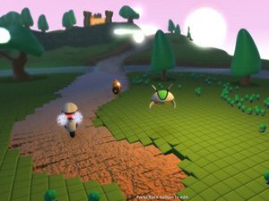
We use Microbits multiple times with KS2 classes. Children can also spend time in after school club experimenting with the input sensors, lights and sounds of the BitBot robot car. | 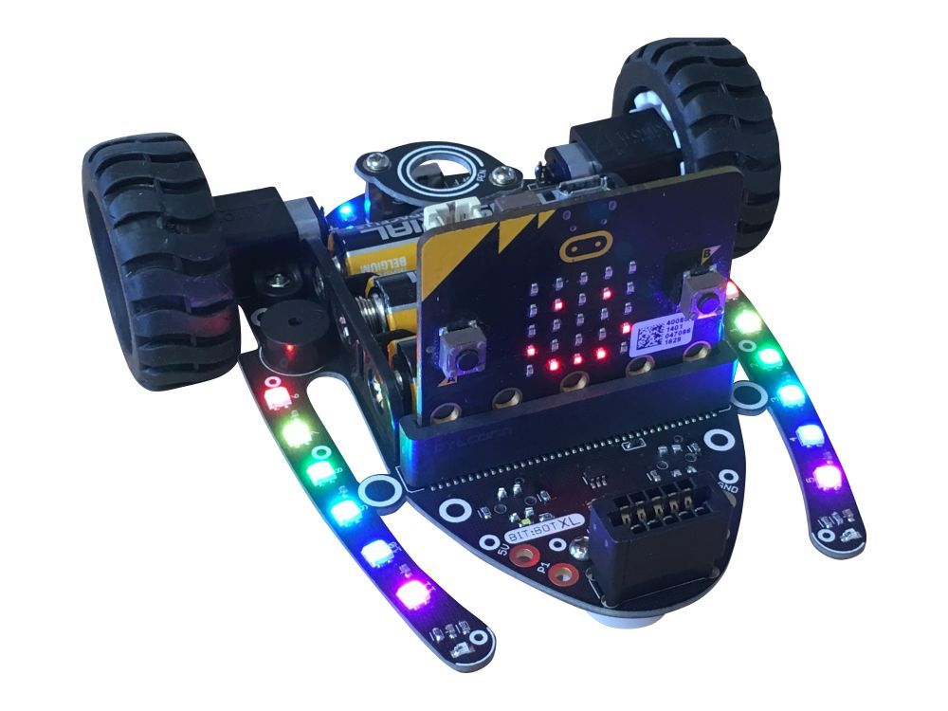

Assessment in Computing:
In every lesson we complete activities which are linked to the National Curriculum strands for Computing. Assessments are made throughout the year and tracked on a central tracking grid. Progress is tracked every term against National Curriculum key stage descriptions.
The three fundamental strands in the new curriculum called “Pillars of Progression” are computer science, information technology and digital literacy. All assessment decisions are linked directly to these strands.
Children complete written work as well as computer based activities which are used together to make assessments. We often use the technology to make the learning interactive for example when we do low stakes quizzes in lessons which are fun and engaging for children but also allow me to instantly identify areas of misunderstanding which can be addressed immediately.

